**Exception Assignment**

I created a custom exception called **MerchandiseException.**

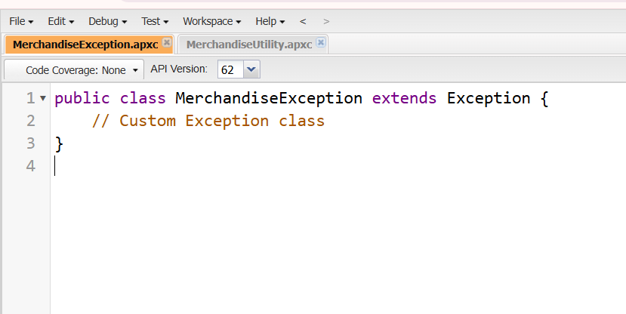

And, Second exception I created named **MerchandiseUtility**

This class will contain the **mainProcessing** method, which calls **insertMerchandise**. The **insertMerchandise** method will insert a Merchandise record without required fields, which will trigger a DML exception. This exception will then be caught and re-thrown as a **MerchandiseException**.

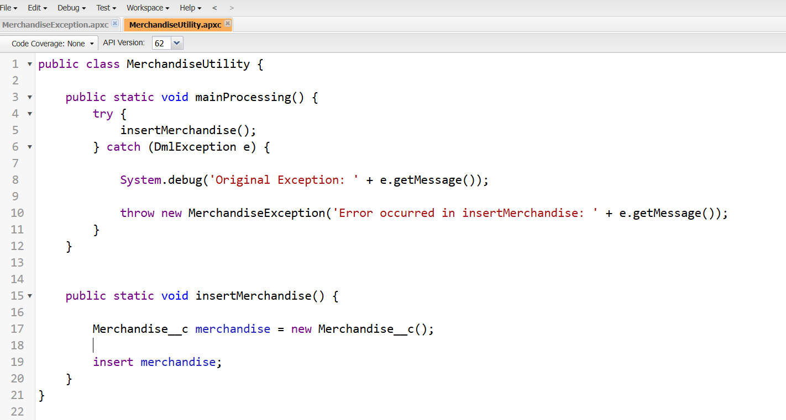

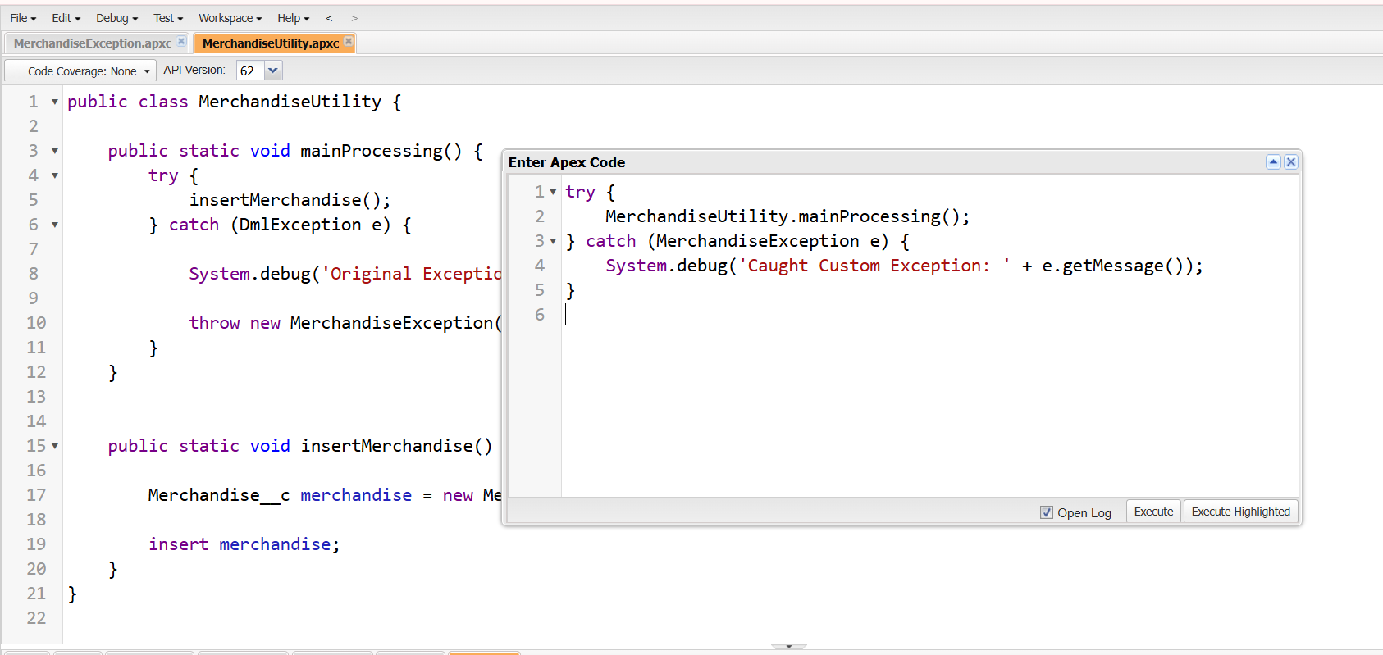

**Output:**

